Distributed Task Notification and Worker System

Team Members:
PES2UG25CS405-Preetham S
PES2UG26CS827-Vivek S G
PES2UG25CS904-Prakruti Sudarshan

Problem Statement:
Develop a distributed task-processing system where workers receive tasks and submit results through TCP sockets. SDN should manage worker communication based on workload.

Problem Understanding & Architecture
- Project Objective: To design, implement, and evaluate a distributed task notification and worker system using low-level TCP socket programming integrated within a Mininet-based network environment.
- System Architecture Overview: The system follows a centralized broker-worker model operating over a virtual network. It consists of three primary software components:
  - topo.py (Custom Topology): Defines the virtual network topology containing a central broker host (10.0.0.10), multiple worker hosts (w1 at 10.0.0.1, w2 at
10.0.0.2), and an Open vSwitch switch connecting them.
  - broker.py (Central Server): Listens for incoming TCP connections, manages worker registrations, tracks active connections, and dispatches tasks. o worker.py (Client Node): Connects to the broker, registers its identity, listens for assigned tasks, executes payloads, and reports results back.
- Communication Flow: Nodes communicate via reliable TCP socket streams using an application-level JSON protocol delimited by newline characters (\n).

TCP Socket Implementation
- Socket Programming: Implemented using Python’s low-level socket library (socket.AF_INET, socket.SOCK_STREAM) to establish reliable point-to-point connections over TCP.
- Concurrency: The broker utilizes Python's threading module (threading.Thread) to handle multiple concurrent worker connections simultaneously without blocking.
- Protocol Message Exchange:
  - REGISTER: Sent from a worker to the broker upon initial connection ({"type":
"REGISTER", "worker_id": "worker_1"}).
  - TASK: Dispatched from the broker to assign a workload ({"type": "TASK", "task_id": "...", "payload": "..."}). o RESULT: Sent back from the worker to report completion ({"type": "RESULT",
"task_id": "...", "result": "..."}).
- Error Handling: Graceful exception handling and cleanup routines ensure disconnected sockets are safely closed and resources are reclaimed.

Mininet & SDN Network Implementation
- Environment: Deployed and tested inside an Ubuntu virtual machine running Mininet and Open vSwitch (OVS).
- Topology Configuration (topo.py): Configured with an OVS switch operating in standalone mode (failMode='standalone') to ensure seamless local packet forwarding and namespace isolation.
- Socket-SDN Integration: End-to-end integration is verified by launching application processes inside distinct Mininet host namespaces (broker, w1, w2), proving that the socket application successfully routes over the virtualized data plane.

Initial Testing & Demonstration Results
- Test Case 1: Single Worker Connection & Registration o Action: Start broker.py in the background and launch w1.
  - Result: Successful TCP handshake, connection confirmation, and registration response ({'status': 'REGISTERED'}).
- Test Case 2: Multi-Worker Concurrency & Task Dispatching o Action: Launch both w1 and w2 concurrently alongside the broker.
  - Result: The broker independently handles multiple active worker threads, automatically dispatches tasks, and logs successful result reporting from each
  - worker in parallel.

Execution and Testing Commands:

- Clean Environment State:
sudo mn -c
- Initialize the Virtual Network Topology
sudo python3 topo.py
- Launch the Central Broker
mininet> broker python3 broker.py &
- Connect the Worker
mininet> w1 python3 worker.py worker_1 10.0.0.10 &
mininet> w2 python3 worker.py worker_2 10.0.0.10
- Terminate the Simulation
(ctrl+c) Command 2: mininet> exit

Output:
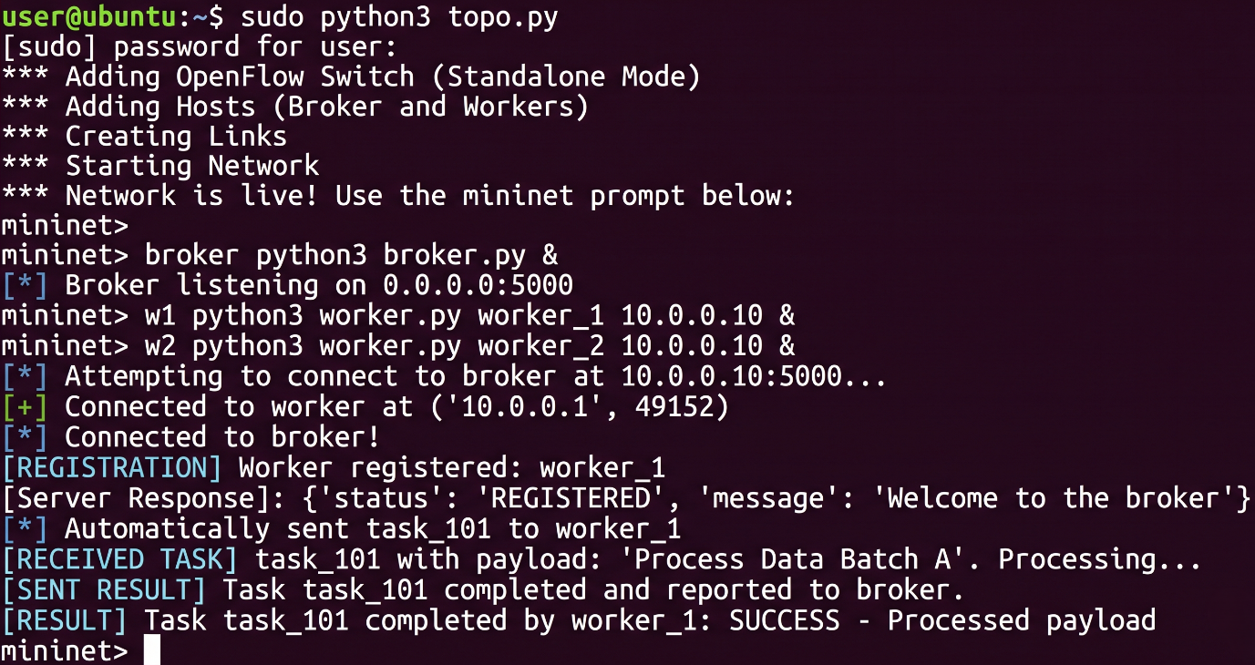

Source Codes:

- broker.py
- import socket
- import threading
- import json
- import time
5.
6. HOST = '0.0.0.0'

PORT = 5000

8.
9. active_workers = {}
10.
- def handle_worker(conn, addr):
- print(f"\n[+] Connected to worker at {addr}") 13. worker_id = None
- try:
- # 1. Receive registration 16. data = conn.recv(1024)
- if not data:
- return
- message = json.loads(data.decode('utf-8'))
- if message.get("type") == "REGISTER":
- worker_id = message.get("worker_id")
- active_workers[worker_id] = conn
- print(f"[REGISTRATION] Worker registered: {worker_id}")
24.
- # Send welcome response
- response = {"status": "REGISTERED", "message": "Welcome to the broker"}
- conn.sendall((json.dumps(response) + "\n").encode('utf-8'))
28.
- # 2. Automatically send a task after 3 seconds
- time.sleep(3)
- if worker_id in active_workers:
- task_msg = {"type": "TASK", "task_id": "task_101",
"payload": "Process Data Batch A"}
- conn.sendall((json.dumps(task_msg) + "\n").encode('utf-8')) 34. print(f"[*] Automatically sent task_101 to {worker_id}")
35.
- # 3. Listen for results
- while True:
- data = conn.recv(1024)
- if not data:
- break
- res_message = json.loads(data.decode('utf-8'))
- if res_message.get("type") == "RESULT":
- print(f"\n[RESULT] Task {res_message.get('task_id')} completed by {worker_id}: {res_message.get('result')}")
44.
- except Exception as e:
- print(f"[-] Error with worker {worker_id}: {e}")
- finally:
- if worker_id and worker_id in active_workers:
- del active_workers[worker_id]
- conn.close()
- print(f"[-] Connection closed for {worker_id}")
52.
- def start_broker():
- server = socket.socket(socket.AF_INET, socket.SOCK_STREAM)
- server.setsockopt(socket.SOL_SOCKET, socket.SO_REUSEADDR, 1)
- server.bind((HOST, PORT))
- server.listen(5)
- print(f"[*] Broker listening on {HOST}:{PORT}")
59.
- try:
- while True:
- conn, addr = server.accept()
- threading.Thread(target=handle_worker, args=(conn, addr), daemon=True).start()
- except KeyboardInterrupt:
- print("\n[*] Stopping Broker...")
- finally:
- server.close()
68.
69. if __name__ == "__main__": 70. start_broker()
71.

- worker.py
- import socket
- import json
- import time 4. import sys
5.
- BROKER_IP = sys.argv[2] if len(sys.argv) > 2 else '10.0.0.10'
- PORT = 5000
- WORKER_ID = sys.argv[1] if len(sys.argv) > 1 else "worker_1"
9.
- def start_worker():
- client = socket.socket(socket.AF_INET, socket.SOCK_STREAM)
- try:
- print(f"[*] Attempting to connect to broker at {BROKER_IP}:{PORT}...")
- client.connect((BROKER_IP, PORT)) 15. print(f"[*] Connected to broker!")
16.
- # Register
- reg_msg = {"type": "REGISTER", "worker_id": WORKER_ID} 19. client.sendall((json.dumps(reg_msg) + "\n").encode('utf-8'))
20.
- data = client.recv(1024)
- response = json.loads(data.decode('utf-8')) 23. print(f"[Server Response]: {response}")
24.
25. # Listen for tasks from broker
- while True:
- data = client.recv(1024)
- if not data:
- break
- message = json.loads(data.decode('utf-8'))
- if message.get("type") == "TASK":
- task_id = message.get("task_id")
- payload = message.get("payload")
- print(f"\n[RECEIVED TASK] {task_id} with payload: '{payload}'. Processing...")
35.
36. # Simulate work execution time 37. time.sleep(2)
38.
- # Send result back
- result_msg = {"type": "RESULT", "task_id": task_id,
"result": "SUCCESS - Processed payload"}
- client.sendall((json.dumps(result_msg) + "\n").encode('utf-8'))
- print(f"[SENT RESULT] Task {task_id} completed and reported to broker.")
43.
- except ConnectionRefusedError:
- print("[-] Connection failed. Is the broker running?")
- except KeyboardInterrupt:
- print("\n[*] Disconnecting worker...")
- finally:
- client.close()
50.
51. if __name__ == "__main__": 52. start_worker()
53.

- topo.py
- from mininet.net import Mininet
- from mininet.node import OVSKernelSwitch
- from mininet.cli import CLI
- from mininet.log import setLogLevel, info
5.
- def run_topology():
- # Create network without a controller, using standalone switch mode for native learning
- net = Mininet(switch=OVSKernelSwitch, autoSetMacs=True)
9.
10. info("*** Adding OpenFlow Switch (Standalone Mode)\n") 11. s1 = net.addSwitch('s1', failMode='standalone')
12.
13. info("*** Adding Hosts (Broker and Workers)\n")
- broker = net.addHost('broker', ip='10.0.0.10')
- w1 = net.addHost('w1', ip='10.0.0.1')
- w2 = net.addHost('w2', ip='10.0.0.2')
17.
- info("*** Creating Links\n")
- net.addLink(broker, s1)
- net.addLink(w1, s1)
- net.addLink(w2, s1)
22.
23. info("*** Starting Network\n") 24. net.start()
25.
26. info("\n*** Network is live! Use the mininet prompt below:\n") 27. CLI(net)
28.
29. net.stop()
30.
- if __name__ == '__main__':
- setLogLevel('info') 33. run_topology()
34.

Conclusion:
This project successfully designed and implemented a distributed task notification and worker system, demonstrating the seamless integration of a custom application within a virtualized network environment. By leveraging Python's low-level TCP socket programming and a multi-threaded centralized broker, the system efficiently manages concurrent worker connections, automated task dispatching, and asynchronous result tracking. The development of a custom JSON-over-TCP protocol ensures reliable, structured message exchanges across the network. Furthermore, executing the application instances inside distinct host namespaces within a Mininet topology—backed by an Open vSwitch operating in standalone mode—validates the system's capacity for end-to-end data plane routing without relying on an external controller. Ultimately, this deliverable establishes a robust and scalable foundation that successfully fulfills the core architectural and networking objectives of the mini-project.

